Nexus - Legion of Engineering Solutions
Capstone Project Proposal

Submitted by:
(101903302) Divyansh Goyal
(101903392) Piyush Bawa
(101903296) Sarthak Gupta
(101903055) Tanvi

BE Third Year- COE
CPG No. 196

Under the Mentorship of
Dr. Seema Bawa
Professor, Computer Science and Engineering



Computer Science and Engineering Department
Thapar Institute of Engineering and Technology, Patiala
Jan-Dec 2022
TABLE OF CONTENTS

- Mentor Consent Form 3
- Project Overview 4
- Problem Statement 5
- Need Analysis 5
- Literature Survey 7
- Objectives 9
- Methodology 9
- Work Plan 11
- Project Outcomes & Individual Roles 12
- Course Subjects 13
- References 14

Mentor Consent Form
I hereby agree to be the mentor of the following Capstone Project Team
Project Title: Nexus - Legion of Engineering Solutions
Roll No | Name | Signatures
101903302 | Divyansh Goyal
101903392 | Piyush Bawa
101903296 | Sarthak Gupta
101903055 | Tanvi

NAME of Mentor: Dr. Seema Bawa
SIGNATURE of Mentor: . . . . . . . . . . . . . . . . . . . . . . . . . . . . . . . . . . . .

Project Overview
This website aims to eradicate the hassle of unilateral websites by allowing the students to select and study various domains of their choice on a single platform. Consequently, it should redirect the user to the appropriate dashboard page after a successful login or sign-up. The model should enable personalization via suggestions for the user interest space.
Apart from that, the user should be able to do searches in the following domains:
A roadmap for preparation, course sites, YouTube channels for relevant skills, societies on campus, and their culture, workspace and opportunities inside the campus, books, and research, movies and music, gaming and podcasts, trips and clubs. Content-based filtering makes recommendations based on user preferences for product features. Collaborative filtering mimics user-to-user recommendations. It predicts users' preferences as a linear, weighted combination of other user preferences.
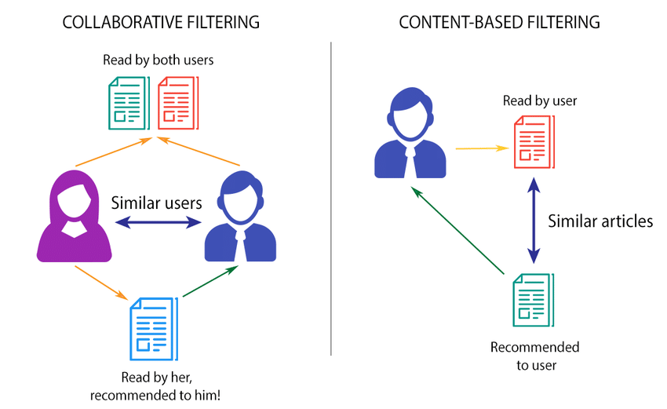
Fig 1. Collaborative Filtering VS Content-Based Filtering [1]
The scope of this project encompasses the interests of the undergraduates at Thapar University. The platform brings the insights of those who have been on this journey to those who are just getting started. We aim to make the students’ experience of this journey exclusive!

Problem Statement
Going to a different website for different material whether it is study-related, or getting recommendations for movies, games, etc is often frustrating. Most students prefer a one-stop solution for their needs. The purpose of this project is to build a website to empower students to build the skills they need. Nexus will introduce students to a roadmap and then resources to achieve the milestones as they proceed – a guided path for learning with everything under one roof.

Need Analysis
When students take admission in an Engineering College, 50% of them come fresh off of having rigorously prepared for JEE and 100% of them come off of preparing for their 12th Board examinations, so religiously that they often don’t have time to gain exposure to the field that they take admission in. Not only this, in their efforts to get into top engineering colleges, students often miss out on a lot in terms of movies, music, books, and games [2]. As a result of this, in most cases, students are astray when they attend college for their first semester. College is the place where they can supposedly catch up with their interests [3], and with all that, they have missed during their last two years, and for that, they need someone to recommend the books, movies, and games. In academics too, they do not have proper guidance as to where to study for the courses which are a part of their curriculum at college [4]. When fresher students enter college, within the first month itself, various societies start their recruitments, and while it might be easier for the students to get into non-technical societies based on their interests, it is difficult to get into the technical ones, especially for those who don’t have any previous experience in programmings, as a result, those who have done programming in school get recruited and receive proper guidance from the seniors in the societies as to how to grow further, while the rejected ones do not have anyone to guide them. Also, freshers attend a lot of seminars organized by various societies where successful people from the same field are called upon to share their journeys and experience as to how and what they did to get to where they are now, while this provides students with an overview of what they need to do to reach the same level as those successful people, they are still left confused as to how to start their journey and what proper resources to follow. Not only do the students miss out on movies, games, and books, but they also have to miss their family trips sometimes [2], as a result, they come to college with high expectations of going on trips with their mates, which does not always turn out to be true. Apart from the freshers, there are many sophomores and junior year students who wish to pursue research opportunities under the guidance of experienced professors to learn from them but are unable to do so, due to the lack of information about the professors who have active research work going on and have vacancies[5].
These are the problems that Nexus attempts to solve. The web app shows the users a complete roadmap to achieve their goal related to the interest they selected while signing up i.e. data structures and algorithms, competitive programming, web development, etc., and corresponding to that, the user would be shown the best resources they should refer to and the order in which to refer to them. Apart from the roadmap, the user would be displayed all the subjects according to their branch and would be able to click them to view the resources to study them. It shows the users, various trips planned by their peers who are looking for more people to tag along with them and allows the users to express their interest in tagging along for the trip. It also allows professors to enter the details of a project they are undertaking and for which they need student volunteers to work and makes that information available to students so that the interested ones can approach those professors. The web application suggests users popular and highly rated movies, music, books, and games for all kinds of platforms, according to what their peers liked. Also, the app makes sure that no student is left uninformed about a society’s upcoming event by providing an online advertisement place for societies to invite participants for their events.

Literature Survey
S.No. | Title | Year | Description | Result
1. | Context-Based Collaborative Filtering for Citation Recommendation[6] | 2015 | A citation recommendation method (CCF) for recommending relevant papers as references of a target paper. | Precision - 55%  Recall - 70%  F1-score - 44%
2. | User-based Collaborative Filtering [7] | 2016 | The items in one specific cluster of users are recommended to the new users whose characteristics are similar to this group. | For 3 clusters:  Accuracy - 80.1%  Precision - 62.02%  Recall - 14.8%  When the number of clusters increases, accuracy, precision, and recall decreases.
3. | Collaborative Filtering Recommender Systems [8] | 2007 | CF technology brings together the opinions of large interconnected communities on the web, supporting the filtering of substantial quantities of data. | The core concepts of collaborative filtering, its primary uses for users of the adaptive web, the theory and practice of CF algorithms, and design decisions regarding rating systems and acquisition of ratings were introduced.
4. | Collaborative Filtering Recommendation on Users’ Interest Sequences [9] | 2016 | The recommendation method in this paper is based on users’ interest sequences, which consider the sequences of users’ behaviors according to the time of their interactions. | The ISCF method has the best performance in predicting users’ ratings to unknown items in all datasets. The effectiveness of interest sequences for improving the precision of the recommendation results is verified.
5. | Mining mood-specific movie similarity with matrix factorization for context-aware recommendation [10] | 2010 | Context-aware recommendation seeks to improve recommendation performance by exploiting various information sources in addition to the conventional user-item matrix used by recommender systems | Mood-specific movie similarity for the recommendation with respect to several evaluation metrics, demonstrating that it could outperform several state-of-the-art approaches.
6. | A new roadmap for social medicine curriculum design based on mixed methods student and faculty evaluations of the preclinical curriculum [11] | 2021 | To support the development of social medicine curricula that empower medical school graduates to redress health inequities, a mixed-methods student and faculty evaluation of an expanded and innovative preclinical social medicine curriculum. | Student and faculty evaluations of an expanded and innovative longitudinal preclinical social medicine curriculum were strongly favorable.

Objectives
- To introduce students to career opportunities through roadmaps for various specializations and propose resources for university courses, career courses, and other vocational interests.
- To update students on vacancies for the research work/projects under faculty and societies on campus.
- To facilitate student forums through an added functionality of discussion panels.
- To update students on recreational interests (eg: movies and series, gaming, and music) using recommendations based on student ratings.
- To let students create tickets for upcoming trips and clubs.

Methodology
- Roadmaps for various specializations and resources for courses: This objective encompasses the elements as mentioned below:
  - Roadmaps for specializations included with well-defined milestones to gain expertise in the respective domain eg: web development, data analytics, etc.
  - YouTube hyperlinks and other online resources added with book references for university courses.
  - Course site proposals for various domains eg: Udemy, edx, etc.
- Vacancies for the research work/projects (under faculty) and societies: Society heads and faculty members shall be allowed access to update the upcoming events and research work/projects on the website.
- Discussion panel: Students can discuss their doubts and queries related to university courses and specialization courses through discussion panels under the respective course sections.
- Update students on recreational interests: Updates and suggestions on recreational space including movies and series, music, and gaming can be broken down as follows:
  - Integrating databases for movies, series, music, and games.
  - Recommendations will be given as per the ratings assigned by the users on the website.
- Upcoming trips and clubs: The organizers should be able to tag upcoming trips and clubs. The use case can be described as follows:
  - Students should be facilitated to create tickets for upcoming trips via a form included on the website.
  - Once submitted, the trip shall be visible to all the users and those interested can click on the ‘Interested’ button under the respective ticket.

Work Plan
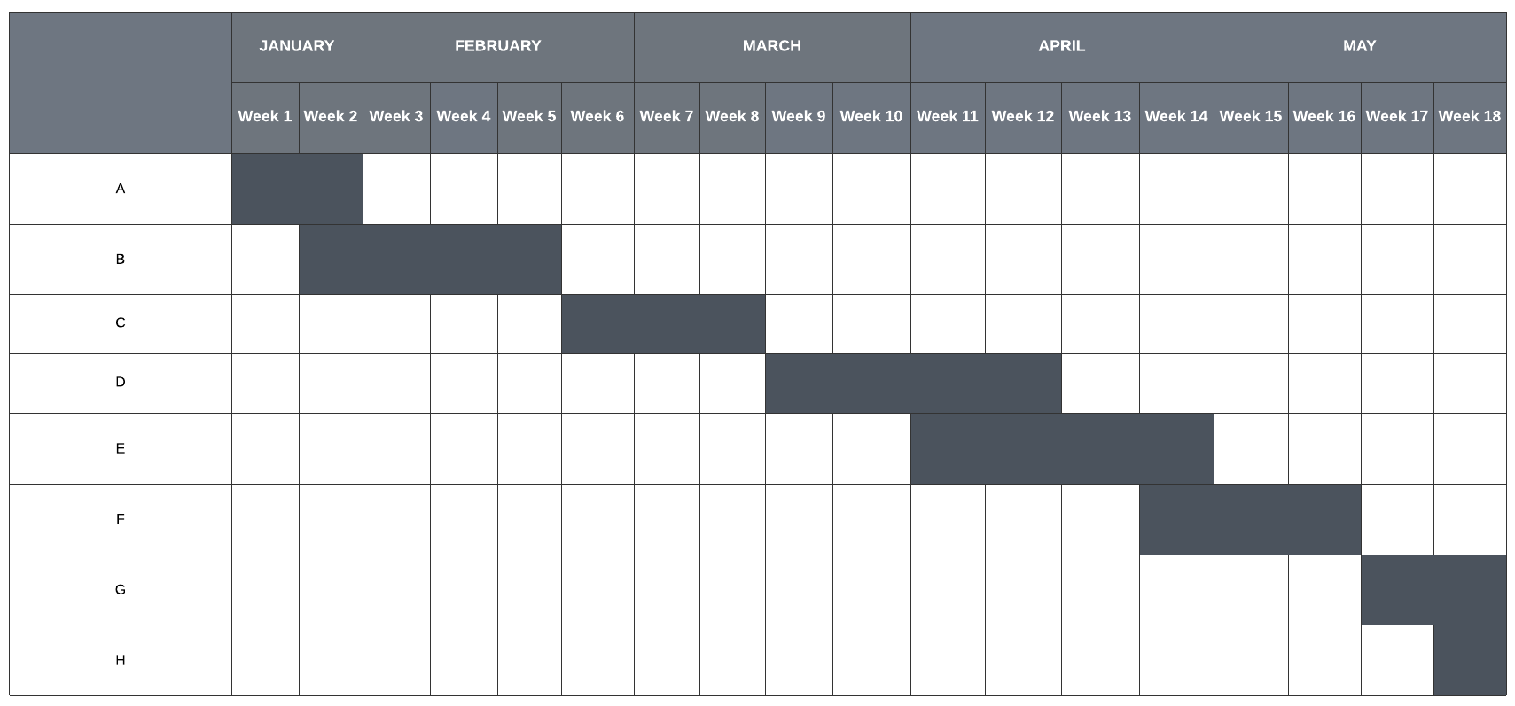
- Construction of roadmaps
- Data collection
- Project creation panel
- Design and execution of discussion panel for students
- Creating databases from the collected data
- Study and design of recommendation system
- Ticket creation space for trips
- Final testing and evaluation of results

Project Outcomes & Individual Roles
The outcome of this project encompass the interests of the undergraduates at Thapar University. This website aims to eradicate the hassle of unilateral websites by allowing the students to explore various domains ranging from career sites to creativity space on a single platform. The website is a host to multiple resources like a roadmap for preparation, course sites, YouTube channels for relevant skills, societies, movies and music, gaming, and books. The platform brings the insights of those who have been on this journey to those who are just getting started. We aim to make the students’ experience of this journey exclusive!
S.No. | Name | Roll No | Role
1. | Divyansh Goyal | 101903302 | Responsible for Backend development and Machine learning model.
2. | Piyush Bawa | 101903392 | Responsible for the Backend development and Data collection.
3. | Sarthak Gupta | 101903296 | Responsible for the Front-end development and Machine learning model.
4. | Tanvi | 101903055 | Responsible for Data collection and Front-end development.

Course Subjects
The following subjects have been referred for the completion of this project:
- Software Engineering (UCS503)
The idea curation, designing, documentation, implementation, and testing plan will all follow the methodologies and concepts taught in UCS503 making the entire capstone project period robust, efficient, and optimal.
- Database Management System (UCS310)
User login credentials, authentication will all require a database structured by the developer. Here, the concepts learned in the database management system will be applied to ensure the safety and security of data.
- Data Science Fundamentals (UCS538)
Building on the basics of Python programming language and Python libraries taught in UCS538, the team will write the Python scripts used for recommendation systems.
- Machine Learning (UML501)
The Machine learning model will be employed for the recommendation of course references, the code for which will be created by the team.
- Design and Analysis of Algorithm (UCS415)
The Python scripts which are essentially the backbone of the project will also be efficiently and accurately coded using the concepts of UCS417.

References
[1] Lionel Ngoupeyou Tondji, Web Recommender System for Job Seeking and Recruiting African Institute for Mathematical Sciences (AIMS)Senegal (2018)
[2] Soniya Agrawal, “No life, no hobbies, burnout, lost childhood — the price students pay for a prized IIT seat”, (March 2021)
[3] David L. DiLaura, “Being Smart is Not Enough Chautauquas for First-year Engineering Students”, (1996, 1998, 2000, 2001), Page 36
[4] David L. DiLaura, “Being Smart is Not Enough Chautauquas for First-year Engineering Students”, (1996, 1998, 2000, 2001), Page 8
[5] Jane Stout, “Understanding Why Many Undergraduate Students Don’t Participate in Research”, Vol. 30/No. 4, (April 2018)
[6] Haifeng Liu, Xiangjie Kong, Xiaomei Bai, Wei Wang, Teshome Megersa Bekele, Feng Xia, Context-Based Collaborative Filtering for Citation Recommendation, IEEE Access ( Volume: 3) (2015)
[7] HamidrezaKoohi, KouroshKiani, User-based Collaborative Filtering, Electrical, and Computer Engineering Department, Semnan University, Semnan, Iran (2016)
[8] J. Ben SchaferDan FrankowskiJon HerlockerShilad Sen, Collaborative Filtering Recommender Systems, Department of Computer Science, University of Northern Iowa, Cedar Falls, IA 50614-0507 (2007)
[9] Cheng W, Yin G, Dong Y, Dong H, Zhang W Collaborative Filtering Recommendation on Users’ Interest Sequences. PLoS ONE 11(5): e0155739 (2016)
[10] Y. Shi, M. Larson, and A. Hanjalic, "Mining mood-specific movie similarity with matrix factorization for context-aware recommendation", Proc. Workshop Context-Aware Movie Recommendation, pp. 34-40 (2010)
[11] Sheridan M. Finnie, Richard J. Brach, Christina A. Dawson, Samuel B. Epstein, Raghav K. Goyal, Karen M. Lounsbury, Shaden T. Eldakar-Hein & Timothy Lahey, A new roadmap for social medicine curriculum design based on mixed methods student and faculty evaluations of the preclinical curriculum (2021)

